Matplotlib Pyplot
- Matplotlib is an open-source drawing library that supports various drawing types
- You can generate plots, histograms, bar charts, and other types of charts with just a few lines of code
- It’s often used in web application servers, shells, and Python scripts
Pyplot is a Matplotlib module that provides simple functions for adding plot elements, such as lines, images, text, etc. to the axes in the current figure.

Example:
Draw a line in a diagram from position (0,0) to position (6,250):
import matplotlib.pyplot as plt
import numpy as np
xpoints = np.array([0, 6])
ypoints = np.array([0, 250])
plt.plot(xpoints, ypoints)
plt.show()

Result:

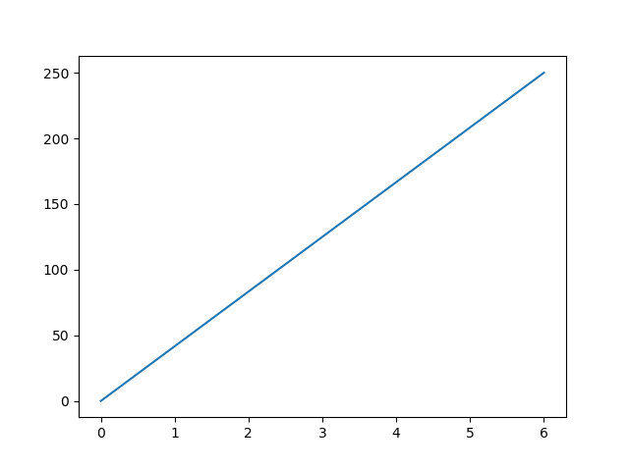

Plotting x and y points
The plot() function is used to draw points (markers) in a diagram.
By default, the plot() function draws a line from point to point.
The function takes parameters for specifying points in the diagram.
Parameter 1 is an array containing the points on the x-axis.
Parameter 2 is an array containing the points on the y-axis.
If we need to plot a line from (1, 3) to (8, 10), we have to pass two arrays [1, 8] and [3, 10] to the plot function.

Matplotlib Markers:
You can use the keyword argument marker to emphasize each point with a specified marker:

Example:
Mark each point with a circle:
import matplotlib.pyplot as plt
import numpy as np
ypoints = np.array([3, 8, 1, 10])
plt.plot(ypoints, marker = 'o')
plt.show()

Result:
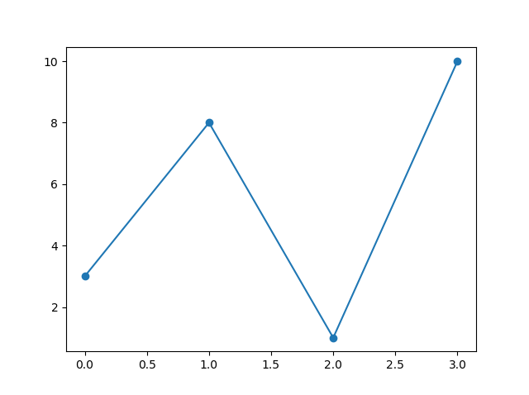

Create Labels for a Plot
With Pyplot, you can use the xlabel() and ylabel() functions to set a label for the x- and y-axis.

Example:
Add labels to the x- and y-axis:
import numpy as np
import matplotlib.pyplot as plt
x = np.array([80, 85, 90, 95, 100, 105, 110, 115, 120, 125])
y = np.array([240, 250, 260, 270, 280, 290, 300, 310, 320, 330])
plt.plot(x, y)
plt.xlabel("Average Pulse")
plt.ylabel("Calorie Burnage")
plt.show()

Result:
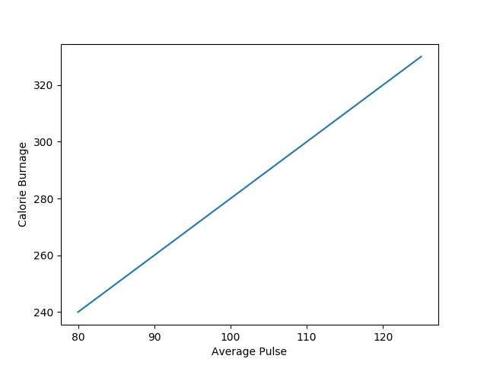

Create a Title for a Plot
With Pyplot, you can use the title() function to set a title for the plot.

Example
Add a plot title and labels for the x- and y-axis:
import numpy as np
import matplotlib.pyplot as plt
x = np.array([80, 85, 90, 95, 100, 105, 110, 115, 120, 125])
y = np.array([240, 250, 260, 270, 280, 290, 300, 310, 320, 330])
plt.plot(x, y)
plt.title("Sports Watch Data")
plt.xlabel("Average Pulse")
plt.ylabel("Calorie Burnage")
plt.show()

Creating Scatter Plots
With Pyplot, you can use the scatter() function to draw a scatter plot.
The scatter() function plots one dot for each observation. It needs two arrays of the same length, one for the values of the x-axis, and one for values on the y-axis:

Example:
A simple scatter plot:
import matplotlib.pyplot as plt
import numpy as np
x = np.array([5,7,8,7,2,17,2,9,4,11,12,9,6])
y = np.array([99,86,87,88,111,86,103,87,94,78,77,85,86])
plt.scatter(x, y)
plt.show()

Result:
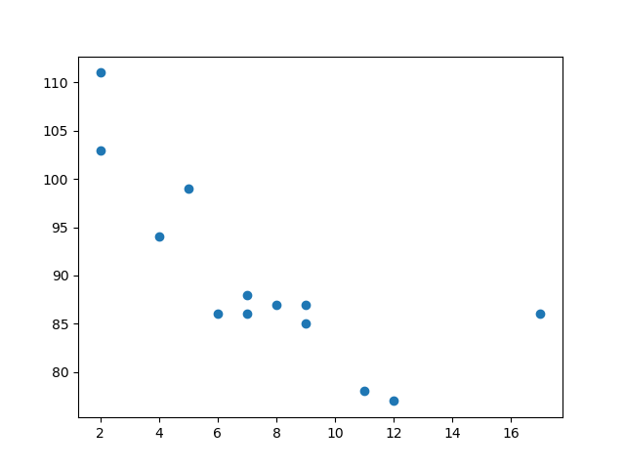

Creating Bars
With Pyplot, you can use the bar() function to draw bar graphs:

ExampleGet your own Python Server
Draw 4 bars:
import matplotlib.pyplot as plt
import numpy as np
x = np.array(["A", "B", "C", "D"])
y = np.array([3, 8, 1, 10])
plt.bar(x,y)
plt.show()

Result:

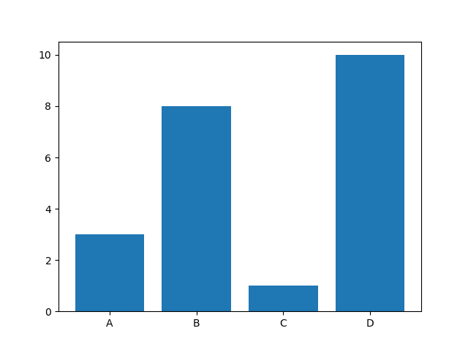

Create Histogram
In Matplotlib, we use the hist() function to create histograms.
The hist() function will use an array of numbers to create a histogram, the array is sent into the function as an argument.
For simplicity we use NumPy to randomly generate an array with 250 values, where the values will concentrate around 170, and the standard deviation is 10.

Example
A Normal Data Distribution by NumPy:
import numpy as np
x = np.random.normal(170, 10, 250)
print(x)

Creating Pie Charts
With Pyplot, you can use the pie() function to draw pie charts:

Example:
A simple pie chart:
import matplotlib.pyplot as plt
import numpy as np
y = np.array([35, 25, 25, 15])
plt.pie(y)
plt.show()

Result:
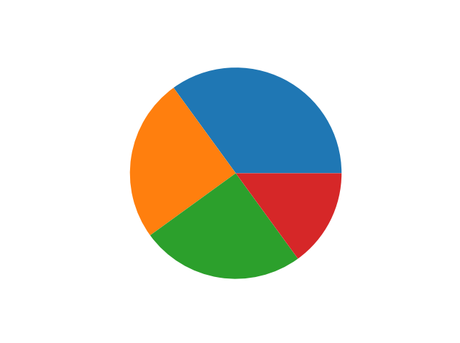
As you can see the pie chart draws one piece (called a wedge) for each value in the array (in this case [35, 25, 25, 15]).
By default the plotting of the first wedge starts from the x-axis and moves counterclockwise:
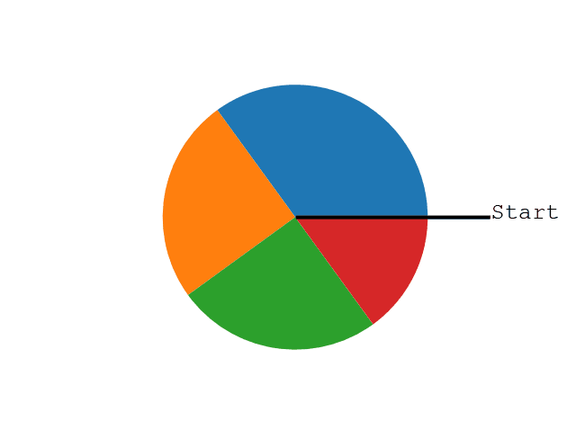
Note: The size of each wedge is determined by comparing the value with all the other values, by using this formula:
The value divided by the sum of all values: x/sum(x)

Labels
Add labels to the pie chart with the label parameter.
The label parameter must be an array with one label for each wedge:

Example
A simple pie chart:
import matplotlib.pyplot as plt
import numpy as np
y = np.array([35, 25, 25, 15])
mylabels = ["Apples", "Bananas", "Cherries", "Dates"]
plt.pie(y, labels = mylabels)
plt.show()

Result:
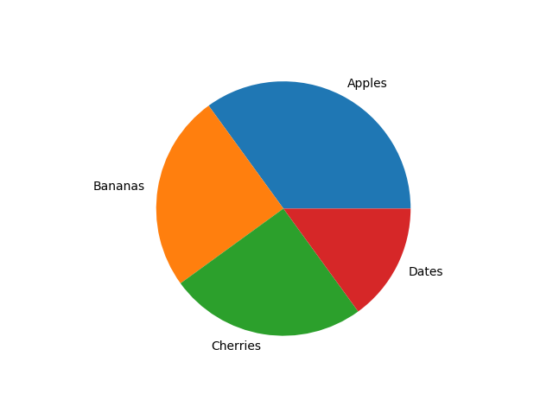

Start Angle
As mentioned the default start angle is at the x-axis, but you can change the start angle by specifying a startangle parameter.
The startangle parameter is defined with an angle in degrees, default angle is 0:
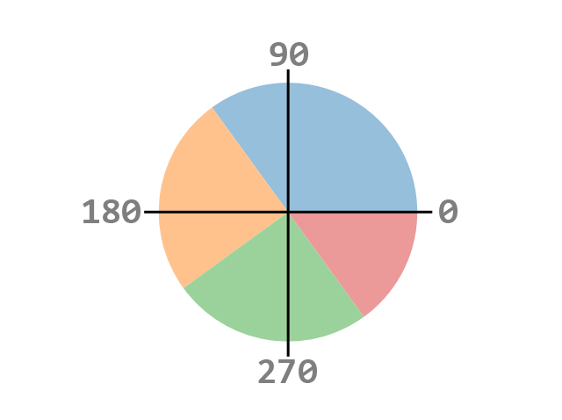

Example
Start the first wedge at 90 degrees:
import matplotlib.pyplot as plt
import numpy as np
y = np.array([35, 25, 25, 15])
mylabels = ["Apples", "Bananas", "Cherries", "Dates"]
plt.pie(y, labels = mylabels, startangle = 90)
plt.show()

Result:
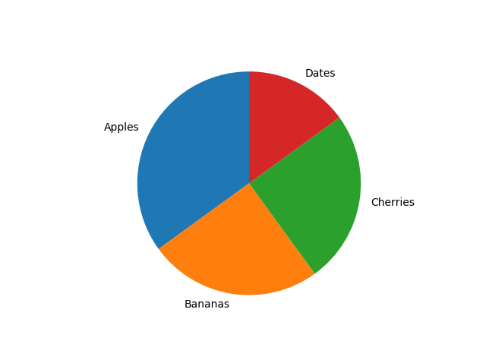

Explode
Maybe you want one of the wedges to stand out? The explode parameter allows you to do that.
The explode parameter, if specified, and not None, must be an array with one value for each wedge.
Each value represents how far from the center each wedge is displayed:

Example
Pull the "Apples" wedge 0.2 from the center of the pie:
import matplotlib.pyplot as plt
import numpy as np
y = np.array([35, 25, 25, 15])
mylabels = ["Apples", "Bananas", "Cherries", "Dates"]
myexplode = [0.2, 0, 0, 0]
plt.pie(y, labels = mylabels, explode = myexplode)
plt.show()

Result:
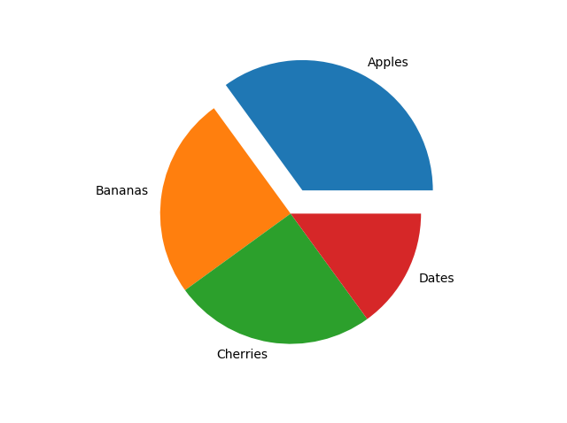

Shadow
Add a shadow to the pie chart by setting the shadows parameter to True:

Example
Add a shadow:
import matplotlib.pyplot as plt
import numpy as np
y = np.array([35, 25, 25, 15])
mylabels = ["Apples", "Bananas", "Cherries", "Dates"]
myexplode = [0.2, 0, 0, 0]
plt.pie(y, labels = mylabels, explode = myexplode, shadow = True)
plt.show()

Result:
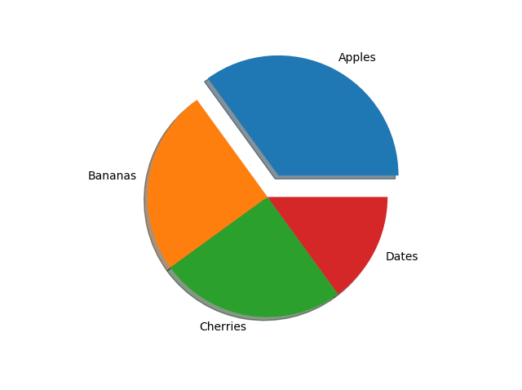

Colors
You can set the color of each wedge with the colors parameter.
The colors parameter, if specified, must be an array with one value for each wedge:

Example
Specify a new color for each wedge:
import matplotlib.pyplot as plt
import numpy as np
y = np.array([35, 25, 25, 15])
mylabels = ["Apples", "Bananas", "Cherries", "Dates"]
mycolors = ["black", "hotpink", "b", "#4CAF50"]
plt.pie(y, labels = mylabels, colors = mycolors)
plt.show()

Result:
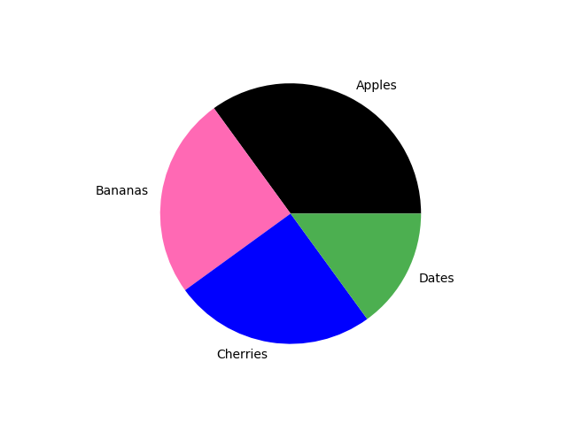
You can use Hexadecimal color values, any of the 140 supported color names, or one of these shortcuts:
'r' - Red
'g' - Green
'b' - Blue
'c' - Cyan
'm' - Magenta
'y' - Yellow
'k' - Black
'w' - White

Legend
To add a list of explanation for each wedge, use the legend() function:

Example
Add a legend:
import matplotlib.pyplot as plt
import numpy as np
y = np.array([35, 25, 25, 15])
mylabels = ["Apples", "Bananas", "Cherries", "Dates"]
plt.pie(y, labels = mylabels)
plt.legend()
plt.show()

Result:
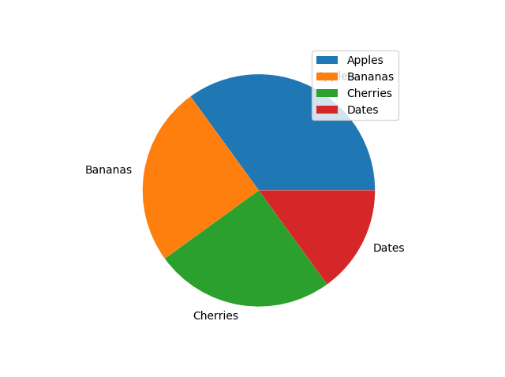

Legend With Header
To add a header to the legend, add the title parameter to the legend function.

Example
Add a legend with a header:
import matplotlib.pyplot as plt
import numpy as np
y = np.array([35, 25, 25, 15])
mylabels = ["Apples", "Bananas", "Cherries", "Dates"]
plt.pie(y, labels = mylabels)
plt.legend(title = "Four Fruits:")
plt.show()

Result:
